Operation Encompass

Cambridgeshire and Peterborough Joint Agency Protocol for Domestic Abuse - Notifications to Schools, Colleges and Early Years settings

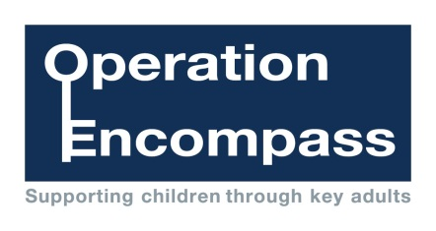

Created: March 2019
Review: September 2019

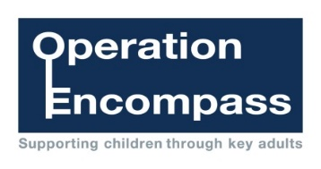




Contents
- Introduction Page 3
- Legal Context Page 3
- Aims Page 4
- Roles and Responsibilities Page 4 – 6
- Schools external to Cambridgeshire and Page 6
Peterborough

Appendix
Appendix 1 Process map Page 7
Appendix 2 Parent letter template Page 8
Appendix 3 Suggested wording for Whole School Page 9

Safeguarding Policy

Appendix 4 Notification template for schools and colleges Page 10
Appendix 5 Signatories to the Joint Agency Domestic Abuse Page 11
School and College Notifications

Please note:

Throughout this document references are made to “children”, “young people” and “pupils”. All refer to children under the age of 18 years.

For ease of reading, references are often made to “school”. This term also applies to other types of educational establishments, e.g. Academies, Further Education (FE) institutions, Sixth Form Colleges, Pupil Referral Units and Early Years settings.

- Introduction
Operation Encompass is a national Police and Education safeguarding partnership enabling support for children and young people who have experienced domestic abuse. Information is shared by the police with the school the day after officers have attended a domestic abuse incident thus enabling appropriate support to be given, dependent upon the needs and wishes of the child.
Children experiencing domestic abuse are negatively impacted by this exposure; domestic abuse has been identified as an Adverse Childhood Experience and can lead to emotional, physical and psychological harm. Operation Encompass aims to mitigate this harm by enabling immediate support, making a child's day better and giving them a better tomorrow.
Operation Encompass believes that children are victims of domestic abuse in their own right and should be acknowledged as such.
This protocol sets out Cambridgeshire and Peterborough’s plans for the multi-agency process for notifying their schools when a child has experienced domestic abuse and violence in their household.

- Legal Context
Government Definition of Domestic Abuse and Violence:
Any incident or pattern of incidents of controlling, coercive, threatening behaviour, violence or abuse between those aged 16 or over who are, or have been, intimate partners or family members regardless of gender or sexuality. The abuse can encompass, but is not limited to:
- psychological
- physical
- sexual
- financial
- emotional

Controlling behaviour
Controlling behaviour is a range of acts designed to make a person subordinate and/or dependent by isolating them from sources of support, exploiting their resources and capacities for personal gain, depriving them of the means needed for independence, resistance and escape and regulating their everyday behaviour.

Coercive behaviour
Coercive behaviour is an act or a pattern of acts of assault, threats, humiliation and intimidation or other abuse that is used to harm, punish, or frighten their victim.
1 in 5 children have been exposed to domestic abuse and it is present in 60% of all serious case reviews. It is estimated that children are present in 80% of incidents.

Information Sharing

Section 11(2) of the Children’s Act, 2004 requires Local Authorities and the Police to safeguard and promote the welfare of children.

All authorities must operate in compliance with the Data Protection Act (DPA) 2018/General Data Protection Regulation (GDPR). The relevant sections in respect of this Joint Protocol are:

Data Protection Act 2018 (DPA)/General Data Protection Regulation (GDPR) | Under Article 6 of the GDPR – Processing Personal Data  - (e) Processing is necessary for the performance of a task carried out in the public interest or in the exercise of official authority vested in the controller.  Under Article 9 of the GDPR – Processing Special Categories of Personal Data  - (g) Processing is necessary for reasons of substantial public interest.  Under Schedule 1 of the DPA – special categories of personal data and criminal convictions etc. data  - Part 2, Section 18 – safeguarding of children and of individuals at risk

Personal data shared must be proportionate, necessary but not excessive, and must be balanced with the consideration of privacy rights under the Human Rights Act. It must take into account any duty of confidentiality owed. A public interest in disclosure must outweigh an individual`s right to privacy.

3. Aims (See Appendix 1 for process)
The aim for Cambridgeshire and Peterborough is to notify schools of any domestic abuse/violence incidents reported to the police involving children on their roll by 9am the following working/school day or as soon as possible thereafter. It is a multi-agency operation between Cambridgeshire Constabulary, Cambridgeshire County Council, Peterborough City Council and the schools and colleges in Cambridgeshire and Peterborough. The police will share details of all domestic abuse incidents (crime/non-crime, and Standard, Medium and High risk) where a child is present with the Education Safeguarding Team’s Navigator within the Cambridgeshire MASH (Multi-Agency Safeguarding Hub). This information will then be shared via secure email with the school’s Designated Safeguarding Lead (DSL) or Domestic Abuse Lead (DA Lead). The school will then decide on the most appropriate support for that child during what could potentially be a difficult day for them.
For Early Years settings in Cambridgeshire, the information will be shared with the DSL by telephone where the Navigator is aware which setting the child attends.
The police will routinely share incidents that are rated as medium/high risk with Children’s Social Care. If schools have additional concerns about the child/children, they should refer to the Effective Support for Children and Families in Peterborough and Cambridgeshire (Threshold document) and consider whether services are required under Early Help to support the child and their family. If indications are that the child is at significant or immediate risk of harm then an automatic immediate referral to Children’s Social Care should be made.

4. Roles and Responsibilities
Cambridgeshire Constabulary and Cambridgeshire Education Safeguarding Team Responsibility:
Cambridgeshire Constabulary, via the Police Domestic Abuse (DA) desk within the MASH, will provide the Education Navigator with a daily spreadsheet of domestic incidents where a child was present. The Education Navigator will then search available systems to establish the education provider for the child and then send an email notification to the relevant school safeguarding contact as near to 9am as possible. NB. For early years settings in Cambridgeshire, the notification will be made by telephone.
Incidents which occur on a Monday, Tuesday, Wednesday or Thursday will be reported to schools and colleges by 9am or as soon as possible thereafter. Incidents which occur on Friday, Saturday and Sunday will be reported by 9am or as soon as possible thereafter on a Monday or the following working day.
The following information will be shared:
- The fact that the police were called out in the last 24 hours or the next working day if it occurs on a Friday/Saturday/Sunday to a domestic abuse incident where a child was present, witnesses or was involved;
- The time and date of the event;
- Brief circumstances surrounding the event;
- The names and dates of birth of any child from that school or college who were present, witnessed or were involved when the incident occurred;
- The relationship of the parties involved to the children; and
- Any other relevant safeguarding information that may assist the school or college to provide early intervention support to the child being referred.
The school will record this information on their chronology for the child/ren and store this in the school’s child protection recording system in accordance with their safeguarding procedures.
Records of the information shared with the Education Navigator will be recorded by the Police DA desk for audit and management information purposes. Similarly, the Education Navigator will retain details of all notifications shared with schools on a corresponding spreadsheet.
School Holidays:
Notifications will not be sent during periods when schools are not open; i.e. Half – term and seasonal holiday periods. However, if an incident is assessed as high risk requiring an urgent response, the Education Safeguarding Manager will be informed in order to make immediate contact with the relevant school or setting.
Schools’ roles and responsibilities:
Schools must have a trained DSL with responsibility for safeguarding within the school who is part of the Senior Leadership Team. Schools and colleges in Cambridgeshire and Peterborough are also provided with additional training from the Education Safeguarding Team to act as the DA Lead in a school or college. All schools and colleges have access to the Education Safeguarding Team’s ‘Domestic Abuse Guidance for Early Years, Schools and Colleges’ and DA Lead training.
In order for the operation to work effectively, it is important that the Education Navigator holds an up to date list of those DSLs and DA Leads.
The information shared does not duplicate or replace any safeguarding interventions that may occur following police involvement. The purpose is to provide schools with important information, so they are able to better support the child/ren appropriately following what is likely to have been a traumatic experience. By sharing this information, it is hoped that children will receive quick and targeted emotional support at the earliest opportunity as required.
Schools will make sure their DSL or DA Lead is available to receive notifications before 9am or as soon as possible thereafter.
It is recognised that the handling of confidential and sensitive information needs to be dealt with in a way that is proportionate and appropriate to the needs of the child/young person and family. To address this, staff receiving the information must have accessed the DSL and/or DA Lead training.

Consideration will be given to which other members of staff may need this information. Only relevant, proportionate and accurate information will be shared appropriate to each individual case and acting in the best interests of the child/ren.
In summary, schools responsibility is to:
- Ensure there is a DSL or DA Lead within the school or college and that they have attended the appropriate training prior to receiving notifications.
- Ensure the DSL/DA Lead is available to receive any notifications as required.
- Ensure they keep an accurate record of each notification and store it utilising the current process used to record child protection information within the school or college.
- Provide appropriate support to a child, following a notification.
- Consider whether a referral to Early Help or Children’s Social Care is needed.

5. Schools external to Cambridgeshire and Peterborough
Where a report is received regarding a child who resides in Cambridgeshire or Peterborough but attends an out of county school then this information will not be shared as they are not covered by this Protocol.

Appendix 1 – Process map
Notification process for schools and colleges for Domestic Abuse incidents

This process intends to notify schools and colleges before 9am or as soon as possible thereafter where a child has been witness, present or involved in a domestic incident, where police have attended. This process does not replace existing child protection/safeguarding arrangements
Police attend domestic abuse incident
Details of the incident are taken, including all present and witness

Details recorded / Domestic Abuse, Stalking and Harassment (DASH) assessment completed
Daily spreadsheet completed and sent to MASH Education Navigator

Education Navigator completes system checks and Education establishment identified

MASH Education Navigator sends notification via email to the DSL /DA Lead at the identified school before 9am or as soon as possible thereafter. Monday’s report will include all incidents that occurred Friday - Sunday

Excel spreadsheet to be updated by Police MASH staff. Incident number, school and DSL/DA Lead to be recorded

DSL/DA Lead to record information on chronology and place on file

School to determine and deliver appropriate support

Appendix 2 – Parent letter Template
INSERT SCHOOL LOGO

Dear Parent / Carer

I am writing to inform you that the school/college will be taking part in a jointly run operation between Cambridgeshire County Council, Peterborough City Council, Cambridgeshire Constabulary and our school/college, which is called Operation Encompass. Encompass has been set up to help schools and colleges to provide support to children who have been present at incidents of domestic abuse and violence. We know that children can be significantly physically or emotionally harmed when they are involved in, present at or are a witness to domestic abuse.
The school/college will receive a confidential, secure email from Cambridgeshire’s Education Safeguarding Team, now working across both Cambridgeshire and Peterborough, before 9am or as soon as possible on the morning after any domestic incident which Cambridgeshire Police have attended where a child at their school/college has been involved in, present at or witness to domestic abuse.
The school/college has Designated Safeguarding Leads who have received training from the Education Safeguarding Team to allow them to use the information that has been shared to ensure that the right support is available for children and their families who have been involved in or have witnessed such incidents.
We are keen to offer the best support possible to our pupils and we believe this is going to be extremely beneficial for all those involved.
If you have any concerns or questions, then please contact ……………………….. and we will be happy to discuss this further. Further information about the project can be found on our school/college website and is available from the school/college office on request.
Yours sincerely,

Appendix 3 – Suggested wording for Whole School Safeguarding Policy

At [Insert Name of School] we are working in partnership with Cambridgeshire Police and Cambridgeshire County Council/Peterborough City Council (delete as appropriate) to identify and provide appropriate support to pupils who have experienced domestic abuse in their home; this scheme is called Operation Encompass.
In order to achieve this, Cambridgeshire’s Education Safeguarding Team will share police information of all domestic incidents, where one of our pupils has been present, with the Designated Safeguarding Lead(s) (DSL)/Domestic Abuse (DA)Lead. On receipt of any information, the DSL/DA Lead will decide on the appropriate support the child may require.
The Operation Encompass information is stored in line with all other confidential safeguarding and child protection information. All information sharing and resulting actions will be undertaken in accordance with the ‘Cambridgeshire and Peterborough Joint Agency Protocol for Domestic Abuse – Notifications to Schools, Colleges and Early Years settings’.

Appendix 4 – notification template for schools and colleges

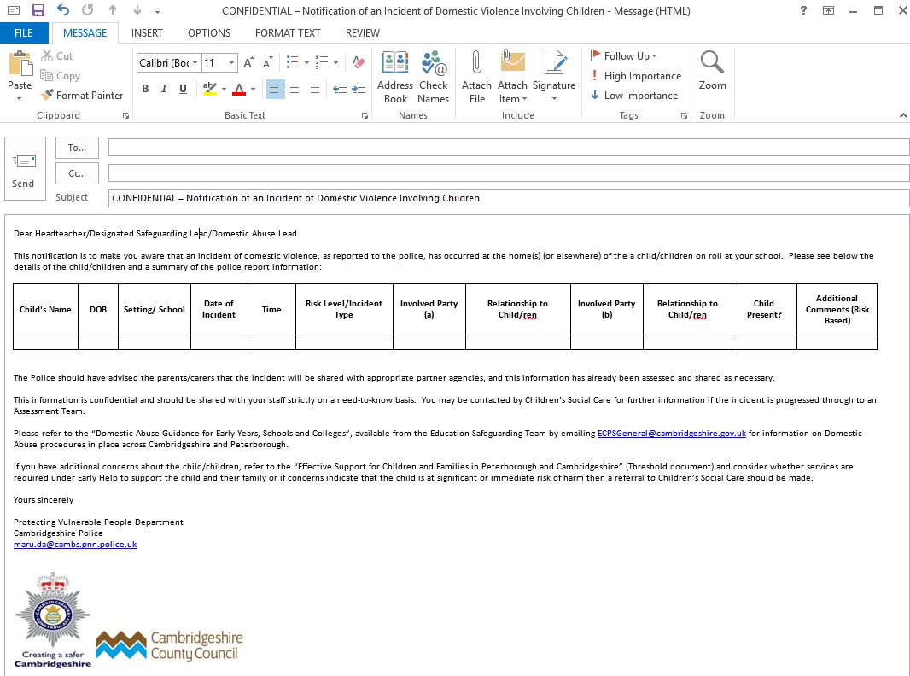

Appendix 5 - Signatories to the Joint-Agency Domestic Abuse School Notification


Signed: Date: 29/04/19

Name: JONATHAN LEWIS

Title: Service Director – Education
Cambridgeshire County Council / Peterborough City Council
Signed: Date: 29/04/19

Name: LAURA KOSCIKIEWICZ

Title Head of Protecting Vulnerable People Department

Cambridgeshire Constabulary
Signed: Date: 29/04/2019

Name: NICOLA CURLEY

Title: Assistant Director, Children’s Social Care, Peterborough

